CNN Object Detection Model Quantization for Reaching Real-Time Inference Speed on Tiny Edge Devices

Introduction
DNN have been reported to demonstrated substantial enhancements in numerous application areas such as CV, ASR, or other related fields. In general, one type of DNN that has achieved best performances for the computer vision applications is cnn with application in object recognition [1,2,3,4] and detection [5,6,7]. The applied CNN give reasonable predictions of object recognition and detection that are of practical value. Parallel to the recent improvements in recognition, other exciting novelties are occurring in virtual reality (VR by Oculus) [8], augmented reality (AR by HoloLens) [9], and smart wearable devices. Combining these two parts of the paper, we suggest that it is high time to make bouts of smart portable devices with the recognition systems of the highest performance.
However, CNN based recognition systems require huge memory as well as computational resources. They are good enough when managed on powerful and costly systems with GPUs but do not work so well on other systems like cell phones and embedded gadgets. For instance, AlexNet [1] has 61M parameters (249 MB of memory) and consumes 1.5B high precision operations to classify one image. These numbers are even higher for deeper CNNs e.g.,VGG [2] section 4.1. These models quickly overload what little storage, battery life, and computing power is available in today’s smaller end point devices, such as smart phones.
There is a fairly clean division of approaches in this field into two. The first category that partly belongs to this constellation is represented by MobileNet [10], SqueezeNet [11], ShuffleNet [12], and DenseNet [13], that propose new approaches to architecture design aiming at the efficient expenditure of computations and memory. The second category quantizes the weights and / or activations of a CNN from 32-bit floating-point number into lower bit depth. This methodology adopted in the classification of networks as Ternary weight networks (TWN [14]), Binary Neural Networks (BNN [15]), XNOR-net [16], and others [8, 17,18,19] is an area of interest to this research. That being said, these quantization methods, available today, have two gaps as to the trade-off of latency against accuracy.
First, it should be noted that previous methods were never tested against a reasonable baseline architecture. Attributed to their intended ability to deliver slight accuracy improvements, the baseline architectures established across practices include AlexNet [20], VGG [21] and GoogleNet [22] are all over-parametrized in principle. This is why they are relatively simple to compress even by hundreds in size — the nature of quantization experiments on these architectures can at most be glorified proof of concepts. A better way to evaluate such more meaningful challenge would be to quantize model architectures which already have a good trade-off rates of latency to that of the accuracy such as the Mobile Nets.
Second, a large number of methods used in quantization fail to provide provable performance gains in real devices. Approaches that quantize only the weights belong to on-chip storage mainly [2, 4, 8, 23]. An exception comprises of binary, ternary and bit-shift networks [14, 22, 24]. These latter approaches use weights that are either 0 or powers of 2 and thus these helps support such operations as multiplication using bit shifting. However, although the bit-shifts can efficiently operate in the custom hardware, no benefits involve the different existing hardware that has the multiply-add instructions unless pipelined where they are not costlier than the standard additions. Furthermore, multiplications are only costly when the operand sizes are wide and the requirement to avoid them reduces with bit depth for quantized weights and activations. More worryingly, these approaches seldom offer on-device measurements to confirm the timing enhancements that they deliver. Slightly more runtime-friendly equivalents adjust both the weights and the activations into 1-bit representations [14, 25, 26]. With these approaches, both multiplications as well as additions can be performed using effective bit-shift and bit-count operations that are illustrated in the custom GPU kernels BNN [14]. However, when 1-bit quantization is used, there is a significant impact on performance and it might be overly critical of the model representation.
AI is the most growing technology and has made people to use computer vision in different fields such as healthcare, agriculture and security and self-driving vehicles. Object detection is one of the fundamental duties of the computer vision that deals with identification of the object along with its position within an image or video frame. In the past, conditions for object detection were solved using deep convolutional neural networks (CNNs) that now provide very high accuracy rates but require large amounts of computational power and memory. These requirements can be met with large, high-end systems but present challenges to deploy on small form factor devices, such as edge devices, the IoT, drones and smartphones which are resource constrained both in computation and energy [1, 2].
Real time inference at the edges of devices has therefore emerged as crucial as more and more application require timely processing and decisions rather than waiting for the cloud. However, there are some issues when it comes to transfer such systems to edge devices, these include; limited memory, weaker processing power, and reduced battery capacity [6]. Model quantization, an optimization technique, is seen today as one of the best solutions when it comes to improving the performance of CNN on more limited hardware. Quantization narrows the precision of computational and memory operations within the neural networks and in change, it facilitates the efficiency of inference computations with relatively low accuracy loss [4,5].
Quantization has become a popular technique in the context of edge computing because it helps to run AI models on hardware and in real-time, while avoiding computations in the cloud. For instance, object detection models can offer desirable levels of throughput that are conceivable for real-time analysis applications for robotics, surveillance, and autonomy [6]. This work focuses on how to utilize quantization approaches for CNN based object detection models to reduce the inference time on tiny edge devices.

Problem Statement
However, there are a few issues which have limited the development of deep neural networks especially the Convolutional Neural Networks (CNNs) on tiny edge devices; these are high computational and memory demands. Although other architectures such as MobileNet and SqueezeNet have been proposed to build more efficient models, most of the existing quantization approaches mainly focus on over-parameterized models that can provide only limited practical implications for real-world scenarios. In addition, most of these quantization techniques do not provide tangible evidence of better performance on conventional platforms. For this reason, it becomes necessary to work on quantization techniques that equally diminish the model size and the time as well as ensure that use of accurate models on the constrained device shall be sustainable.

Research Questions
- What are the key limitations of current quantization techniques when applied to efficient baseline architectures, such as Mobile Net, in terms of balancing latency and accuracy?
- How do different quantization methods impact the real-time inference speed and accuracy of CNN-based object detection models on tiny edge devices?
- What are the comparative benefits of quantizing both weights and activations versus quantizing only weights in CNN models intended for edge deployment?
- How can novel quantization techniques be developed or adapted to optimize CNN models for specific applications in real-time object detection on edge devices?
- What empirical evidence can be gathered to substantiate the effectiveness of proposed quantization approaches in real-world edge scenarios?

Scope of the study
The area of research for this study is limited to improving CNNs by using model quantization approach for improving the real time object detection on tiny edge devices. It will mainly focus on efficient reference models like MobileNet, SqueezeNet that are aimed at operating in limited environment. Weight and activation quantization methods are likely to be checked together with the mixed strategies that employ both, while examining the effects of the proposed ways on computer performance rate, memory consumption, and model accuracy of CNN. With focus on practical use cases, the research will investigate object detection within a variety of domains: robotics, surveillance, and augmented reality amidst the demonstration of benefits of quantized CNN models in low-latency response centered situations. The paper will also utilise measurements and statistics of real edge devices in order to validate the runtime performance with real life comprehensive results such as speed, accuracy as well as power consumption and other vital resources. Furthermore, a comparison of the current quantization methods will also be performed to compare and contrast their features and problems so as to design new techniques suitable for constrained edge devices. Albeit designed to briefly highlight and compare the current state of the art in quantization techniques, the investigation will not disregard the potential future enhancements as well as emerging research directions which may help to further fine tune CNN models for edge implementation making the subject of real-time object detection significantly richer.

Literature Review

Theory

Machine Learning
With increased uptake of the internet, the number of devices continues to rise and so does the data. Since, it would almost be impossible for a human being to sort out so much information – if it is full of combinations, then there are created computer algorithms, which find new patterns in this information and make other projections [27]. An introduction to such algorithms roughly constitutes the field of Machine Learning (ML), which is a category of Artificial Intelligence (AI). In practice, it can be defined as the phone may receive certain commands when spoken or may alter the pictures when it recognizes the scene. The tasks look very simply to carry out for human beings, but when it comes to programming the computer to carry out these tasks, it will prove very hard. As such, it is preferable to feed some data to these computers so that they can decipher the valuable information from it [28].
The large Subset of Machine Learning algorithms is mainly categorized into three general classes namely supervised learning, unsupervised learning and reinforcement learning. The simplest one is the supervised learning where is given the training data and the corresponding outputs, we attempt to learn the mapping is from some inputs x to outputs y [29]. An example of the supervised model could be a regression problem, in which we attempt to predict the price of houses from the size of the house in square meters. Of particular interest in this thesis are supervised algorithms and, therefore, the subsequent chapters provide more information about them. As seen in supervised learning, in unsupervised learning we have a dataset but unlike the former, the labels are missing. In this case we cannot predict like in supervised learning, but we would like to identify hidden characteristics of the data, so called latent variables, to categorize our inputs [30].
The last form of Machine Learning is reinforcement learning, where an algorithm is making actions that take place in an environment and learns from its experiences. Every action taken by a given algorithm leads to some state which is then perceived and a relevant reward given depending on whether the state was positive or not [31]. Recent improvements in computation and research in reinforcement learning demonstrate this well as Google’s Alpha Zero are finding ways of solving them by themselves [32].

Neural Networks and Deep Learning
Neural networks are also known as neural models or connectionist models, they were designed to replicate neurons in the human brain. The simplest kind of artificial neuron is called perceptron, the activity of which yields a simple binary value y depending on the dot product of real numbers of the input vector x and vector of weights w added to the bias b as observed in figure 1 below [33].
$y=\{1, ifw.x+b>0, 0, otherwise\},$ (1)
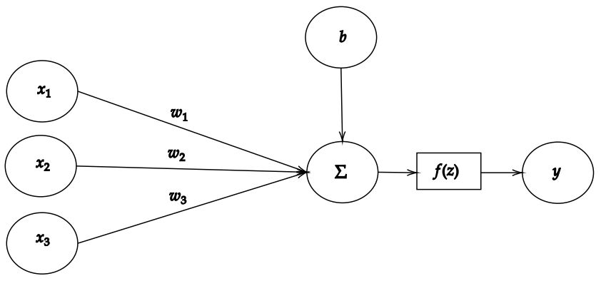
FIGURE 1. Simple perceptron model
Existing since then, this simple perceptron model has been developed further, partly because of inspiration from neuroscience, engineers and mathematicians. In order to introduce the complexity, there is a way to expand the number of neurons in parallel, which allows each neuron to represent something different about the input data [34].
Another method of processing the sensory data, for example the image data, was borrowed from neuroscience where several levels of filtration take place before the data is passed to the visual cortex and shown as an image. From the same it might be postulated that it is necessary to enhance the neural networks that emulate the human brain in terms of information processing to some extent to make them deeper. In a DNN the first layer or the initial layer of the network contains say pixelates of an image which is fed to the subsequent hidden layers then to the output layer which in turn contains the higher-level information about the image [35].
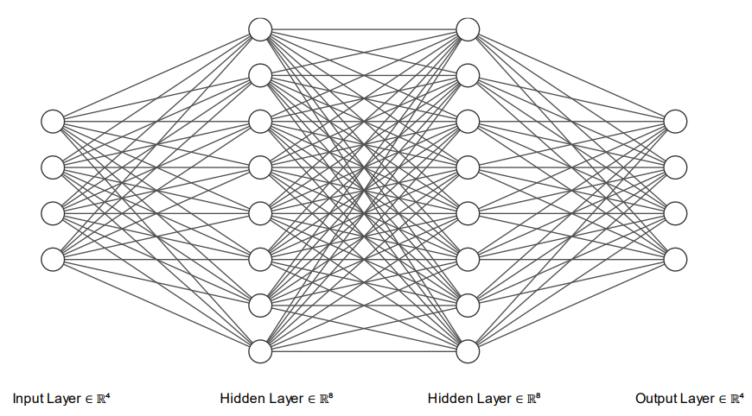
FIGURE 2. Deep Neural Network with 4 layers

Activation functions
Often, we want to solve tasks with non-linear relations or problems where the desired output is a probability, such as the probability of an image containing a cat. To solve these problems, activation functions are introduced to the network. Given a linear input
$z=w. x+b$ (2)
we can transform z into a non-linear output as follows
$y=f(z)$ (3),
where f(z) can be any nonlinear activation function [36]
Activation functions in hidden layers have been researched a lot, and at first, the sigmoid and hyperbolic tangent (tanh) were used a lot. These days the Rectified Linear Unit (ReLU) is the most used as t’s easy to compute, it does not have a problem with vanishing gradients due to being a piecewise function and in addition, it imitates the human neuron activations closely due to saturation at 0, activating only a subset of neurons at a time [37]. The formula for ReLU is defined as follows
$f(z)=max⁡(0, z)$ (4)
At the output layer, the used activation function depends on the task we are trying to solve. For binary classification tasks, we could use the sigmoid activation function mentioned before, which outputs the probability of the input belonging to a class. A special case of sigmoid exists for multi-class classification tasks called SoftMax, which outputs a probability distribution of the classes [38].

Cost function
To analyze how our neural network is performing, we use something called the cost function (or loss function) to measure how big of an error the network is producing in its outputs. Since ideally, we want our network to make perfect decisions, our goal is to minimize the cost [39]. In supervised tasks, this would mean that for an input pair (x, y), where y is the ground-truth value, our model would be able to make a prediction ŷ, that is the same as the ground-truth value when the input is x.
One of the most common cost functions is the Mean Squared Error (MSE) cost function, which can be used for regression problems. The cost is usually averaged over m training examples and is defined as follows
$MSE \left(y, ŷ \right)=\frac{1}{m} \sum_{i=1}^{m}{yi= ŷi)2 }$ (5)
where m = number of training examples, yi = ground-truth value for the ith training example and ŷi = predicted value [40].
When our output is a vector of conditional probabilities, for example, if our output layer uses a SoftMax activation, it would be desired to penalize distinctly wrong outputs more, such as classifying an image of a cat as a bird. As we know that our input values are in the range of [0, 1], we can use something called crossentropy loss, which minimizes the negative log-likelihood and is given by
$L \left(y, ŷ \right)=-\frac{1}{m} \sum_{i=1}^{m}{yi .\log{(ŷi)} }$ (6)
Due to the logarithm, the function outputs a high error when it incorrectly gives a low probability to a class [41].

Backpropagation and Gradient Descent
As the objective of a machine learning model is to minimize the cost function, we must find a way to adjust the weights and biases to achieve this. A way to solve this is to compute the gradient of the cost functions, which is just a vector of partial derivatives with respect to the weights and biases of the network, informing us how much changing each unit in the network by a tiny amount would change the output. The gradient gives us the magnitude and direction of the steepest ascent, so we can iteratively move towards some local minima of the cost function by taking a step towards the negative direction of the gradient. The size of the step is usually given by the learning rate. Too high of a learning rate might not reach the minima of the cost function, and too small of a learning rate might take too long to find the minima, so the learning rate should be tuned correctly. The network can then be updated by an algorithm called Gradient Descent as follows
$θ = θ - η ∙ ∇C$ (7)
where θ = the vectorized parameters of the network, η = learning rate and ∇C = gradient vector of the cost function [42].
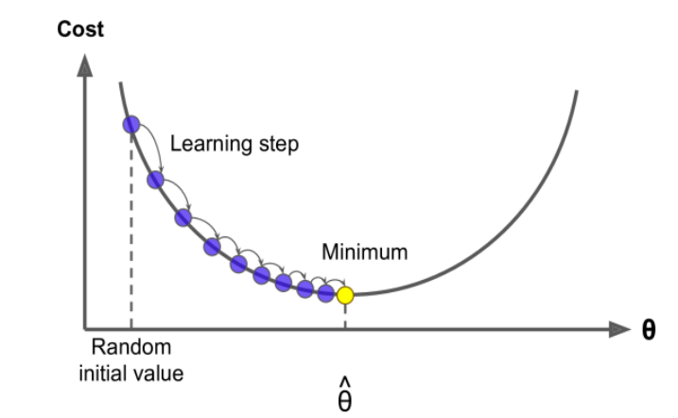
FIGURE 3. Gradient Descent algorithm [43].
The gradient is calculated using an algorithm called Backpropagation, which computes the partial derivates by moving backward in the neural network. The algorithm is preceded by inputting a training example to the neural network (forward propagating) and computing the cost function, after which the backpropagation algorithm is applied. This last step can be seen as propagating backward in the neural network graph due to the chain rule, which is why it is called Backpropagation [44]. For example, the error of the first weight from the input layer with respect to the cost function can be calculated as follows
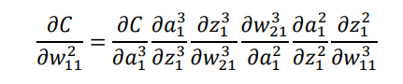 (8)
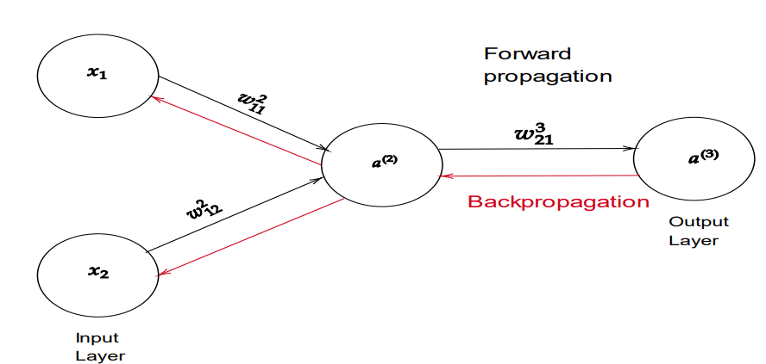
FIGURE 4. Neural network forward propagation and backpropagation
With the regular gradient descent algorithm, the weights are updated after forward propagating every sample and calculating the cost. This however means that it takes a long time to update the network. To speed up the training process, a stochastic gradient descent algorithm is usually applied. Instead of summing over the cost of all the training examples in our dataset, a batch of examples is randomly chosen from the training set and the gradient descent algorithm is applied from the average of the gradients [45].

Convolutional Neural Networks
Convolutional neural networks (CNNs) are the state-of-art method for various computer vision tasks these days. They were developed to better extract information from data such as images, where spatial relations are present. CNNs had been researched since the 1960s, but the first landmarks were by Yann LeCun, who first applied backpropagation to convolutional neural networks in 1989 [46] and also released a paper on the LeNet-architecture [47], which laid the foundations for modern deep learning-based computer vision. CNNs later rose in popularity in 2012, after AlexNet won the ImageNet competition and became the stateof-art model for classification. This was largely due to the rise in computing power and utilizing graphics processing units (GPUs) in training [48].
Compared to regular neural networks, instead of learning weights from each input neuron to each hidden layer neuron, CNNs learn a kernel which we slide and apply through an image in small boxes with a mathematical operation called convolution. This allows us to find patterns in images by not only looking at one pixel at a time but also its surroundings. Convolution is often implemented as cross correlation in CNNs, which performs the same operation, but with the kernel flipped before sliding it over the input and is mainly used to simplify the mathematical equation. Cross-correlation is then defined as follows
$\left(f*g\right)\left(i, j\right)=\sum_{a}{.}\sum_{b}{f\left(a,b\right)g (1+a, j+b)}$ (9)
where f = discrete 2d input such as an image, g = 2d kernel, and i and j are the coordinates which convolution will be calculated at [49].
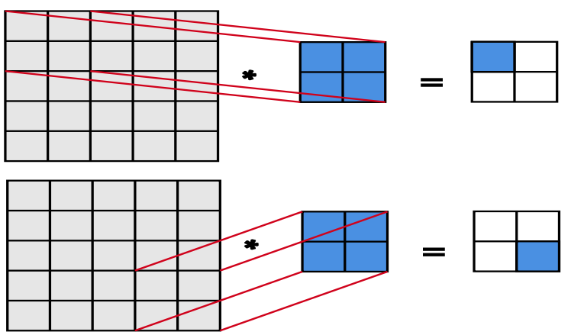
FIGURE 5. Convolutional operation in 2 dimensions
These convolutional operations along with the learned kernels are then used in convolutional layers, where the number of different kernels denotes the depth of the layer. These convolutional layers also help make the model size smaller than a regular dense neural network (DNN), which was seen in Figure 2. As the kernels are shared in the network, we save memory by only having to store weights depending on the size of the kernel instead of the size of the inputs [50].
The different kernels then generate new images from their inputs, which are often called feature maps. Usually, the first convolutional layers of the network find some low-level features of the image, such as edges of the face from a picture of a human face. These are then combined to form larger parts such as an eye and a mouth and then finally an image of the human face with its edges highlighted at the last layer. [51] The feature maps are also passed into activation functions, as was the case with regular neural networks, to introduce non-linearities to the network. An example of a convolutional neural network and its feature maps can be seen in Figure 6.
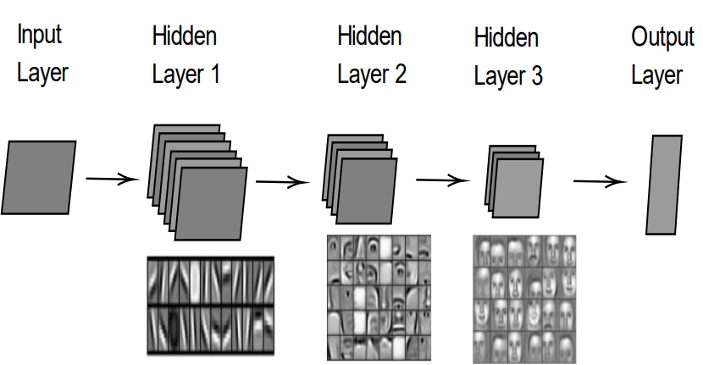
FIGURE 6. Convolutional neural network with hidden layer feature maps visualized. Layer visualizations copied from [52]

Padding and Stride
As we convolve an image with a kernel, our output keeps shrinking relative to the input, as was seen in Figure 5, causing us to gain less information about pixels on the edges after each layer. To avoid this, we pad the input with zeroes so that we can slide the kernel horizontally and vertically as many times as we have pixels in the original input, resulting in an output image that is larger than the original output and containing more information about the edges [53].
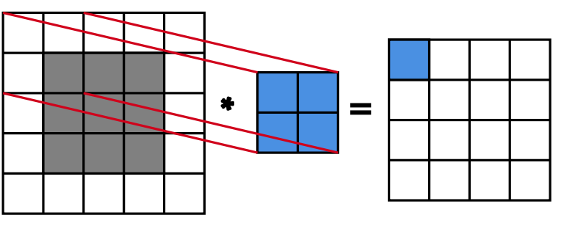
FIGURE 7. Input with padding results in a larger output feature map than in Figure 5
Sometimes it is also desired to reduce the dimensions of the input or speed up the computation, so we downsample by applying stride to the convolution operation. As was seen in Figure 5, we moved the kernel horizontally and vertically by one, which means we had a horizontal and vertical stride of one. To down sample a feature map, we could for example apply a horizontal and a vertical stride of three, as is seen in Figure 8 [54].
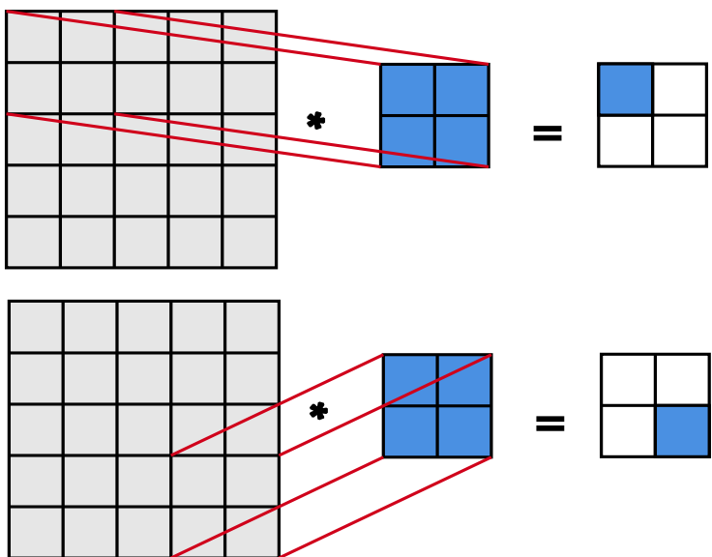
FIGURE 8. Convolutional operation with a horizontal and vertical stride of three

Pooling
Another way to down sample the input image is to apply a pooling layer between the convolutional layers, which has a size and stride like a convolutional layer but computes a function other than a convolution from its inputs, such as an average or a maximum. The most commonly used layer is a max pool layer, where the cell with the biggest value is always selected to the output as the max pooling kernel is slid over the inputs. This is useful, as usually, we try to find edges from the images without feature maps, and sharp features are usually related to high pixel values, thus reducing the input dimension, and finding desired features without having to learn any weights. Another benefit of max pooling is, that it offers some level of translate invariance, meaning that small changes in the location of the pixel can still result in the same output [55]. The max pooling operation is shown in Figure 9.
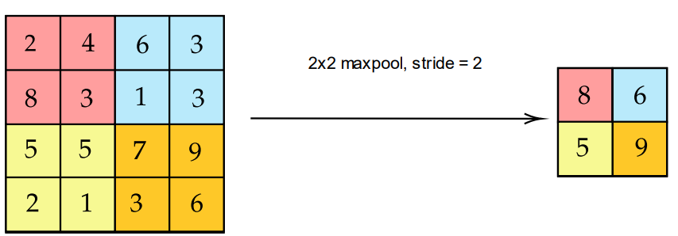
FIGURE 9. 2x2 max pooling with stride = 2

Object Detection at Edge
Object detection is a task of locating and classifying an object or multiple objects in a scene. This can be used e.g., for detecting pedestrians and traffic signs in self-driving cars or traffic behavior in intersections. A real-world deployment example of the latter could be to install a security camera near the intersection, which would then stream the images to a remote cloud center to process the data. This has been the de facto standard for the past decade as cloud computing has become increasingly popular, but it now has its concerns due to vast amounts of incoming data and personal privacy. To deal with these issues, edge computing has grown to be a popular solution alongside cloud computing. The data can be pre-processed at an edge, which is a computing node between the sensor (such as a camera) and the cloud, as is shown in Figure 10.
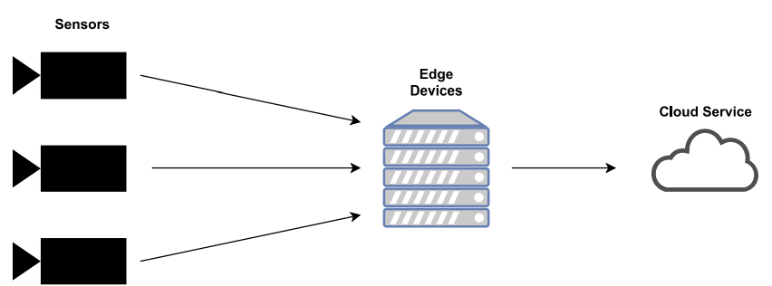
FIGURE 10. Simple edge computing network
The first benefit of this is latency and bandwidth reduction, as we can perform computing ideally in the same network as the devices that operate on this data, reducing the overhead of transferring the data forth and back, which could be crucial in applications such as autonomous cars. The second benefit is being able to process the data before it reaches a third-party cloud environment, like anonymizing faces or hiding unique identifiers from sensitive data. Thirdly we can save storage at large-scale datacenters by filtering data not suitable for postprocessing at the edge [56]. The need for pre-processing and filtering becomes more evident b loo ng at C s o’s numbers, which reported that M2M devices, such as surveillance cameras and smart meters, would account for 50 % of devices and connections by 2023 and were growing the fastest by far [57].

Object Detection
In object detection, we want to be able to input an image to an algorithm, which will then return us the number of detections, bounding boxes that tell us the location of the objects within the image, and classes telling us what kind of objects we have detected and the confidences that an object belongs to the class.
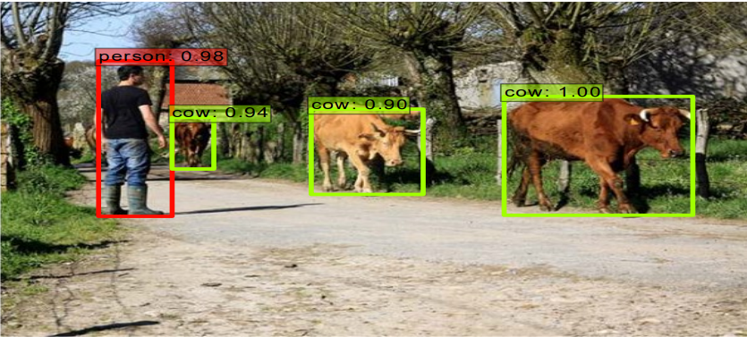
FIGURE 11. The output of a typical object detection model [58]
Object detection has exploded in the last decade due to the growth of convolutional neural networks but has been available for some detection tasks, such as face detection, for nearly two decades. One of the most popular algorithms was and still is the Viola-Jones algorithm, which could detect faces at 15 FPS back in 2001 [59].

Object Detection Architectures
The modern deep-learning-based object detection models started showing promise in 2014 with the release of the RCNN-model. It however was too slow for the majority of real-life use cases, as it consisted of 3 different stages with both convolutional neural network and support vector machine (SVM) classifiers to train [60]. Recent object detection models are generally single-shot detectors, meaning we only must pass the input image through one neural network. These architectures person usually consist of two parts, a base network, and a classification network, with its final classification layers cut off to generate feature maps at different scales. The classification layers are then replaced by a detector network, which generates appropriate bounding boxes and classifications from these feature maps. Figure 12 shows an SSD model [61] with a VGG-architecture base network.
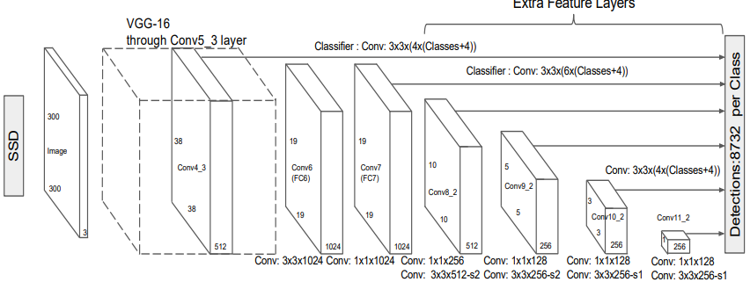
FIGURE 12. SSD Detector with a VGG base network [62]
The larger feature maps, such as the 38x38 layer in Figure 12, attempt to find small objects by dividing the image into smaller segments, while the smaller feature maps try to locate larger objects. As the feature maps often shrink information about the image into more dense representations, each pixel in a feature map can be seen as representing a larger group of pixels in the original input, and thus forming a grid of cells over the original image. An example of this can be seen in Figure 13, where a 7x7 feature map is laid over the input image.
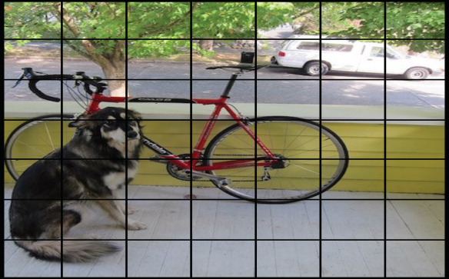
FIGURE 13. 7x7 feature map laid over an input image [63]
Modern object detector models can further be divided into two categories, anchorbased, and anchor-free solutions. The anchor-based solutions, such as SSD [64] or EfficientDet [65], try to predict n bounding boxes for each cell in a feature map by calculating offsets for given a set of hand-engineered default (or anchor) boxes at different scales. The best bounding boxes are then chosen with an algorithm called non-max suppression (NMS). The anchor-free solutions, such as YoloX [66] or FCOS [67], on’t req re manually finding optimal anchor boxes for prediction, and only one prediction is selected for an object even at multiple feature maps levels, as overlapping is further reduced by methods such as setting limits for bounding box sizes at each level.
As an object detection model’s goal is to predict a correct class and a correct location for each object in the scene, the cost function is usually a sum of the classification error and localization error (regression task). For example, in the Fast R-CNN model, the following loss function was used
$Ltotal = Lcls + Lloc$ (10)
where Lcls = SoftMax loss, used for measuring the classification error, and Lloc = smooth L1 loss, used for measuring the localization error [68].

Intersection over union and non-max suppression
In object detection, a prediction is labeled as a true positive, if its bounding box and the ground-truth prediction’s bounding box overlap over a certain threshold. This metric is called intersection over union (IoU, Jaccard index) and is calculated by dividing the overlapping area by the union area of the two bounding boxes
IoU(A, B) = |𝐴 ∩ 𝐵| |𝐴 ∪ 𝐵| , (11)
where A = area of overlap and B = overlapping area. [69]
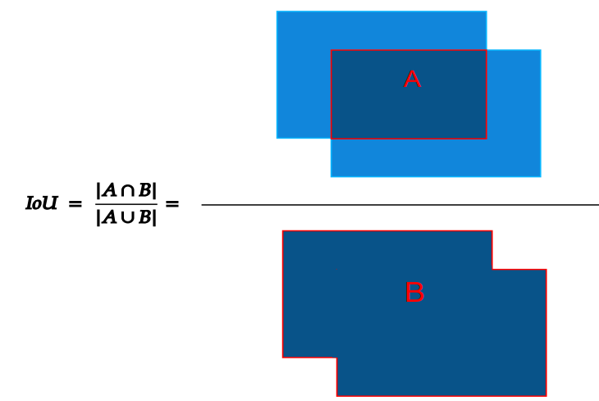
FIGURE 14. Intersection over union
Often the state-of-art models generate up to hundreds of predictions per input image and many of them are overlapping, trying to detect the same object from a different position. Non-max suppression attempts to speed up the processing by making a list of predicted bounding boxes sorted by their confidence, selecting the first one as a reference, and dropping the other bounding boxes in a list if their IoU was over a chosen threshold with the reference bounding box. This process is repeated for all the bounding boxes left in the list, with the ith bounding box chosen as a reference on ith comparison round [70].

Deep Learning Accelerators
Due to the increasing need to perform tasks involving machine learning algorithms in real-time, especially on devices with limited CPU computing capability, chips optimized for edge inference are required. The current deep learning accelerators can be roughly divided into three categories, ASICs, FPGAs, and GPUs.
Both ASICs and FPGAs are application-specific circuits, which provide consistent low latency and power consumption, but have increased complexity in programming [71]. The main differences between the two are, that FPGAs provide flexibility being reprogrammable, while ASICs are more optimized, but single-purpose after production. Current state-of-art deep learning accelerators are ASIC chips such as Google Coral’s Edge TPU [72] or Intel’s Movidius series VPUs (Vision processing unit) [73].
GPUs are also very popular in deep learning tasks, due to their easy programmability, but the trade-off can generally be seen in power consumption and latency [74]. As they usually have lots of cores, they are well suited to parallelizing tasks, such as matrix multiplications and convolutions, which are widely used in neural networks. GPUs can also be utilized in a multitude of ways in a computer vision pipeline, for example in video decoding and encoding in addition to object detection. An example of a Deep Learning Accelerator utilizing GPUs are the NVIDIA Jetson series embedded systems [75], which feature fully-fledged Linux systems for diverse use cases.

Model Quantization
To run deep learning algorithms on edge, the models have to be compressed into lighter versions. Typically, each hardware vendor, such as NVIDIA, has its own deep learning toolkit which compiles an existing model, trained in e.g., TensorFlow, to another format that better utilizes the hardware in the edge device through means like quantization and hardware-optimized layers.
In the case of neural networks, models are typically trained in 32-bit floats (single precision, FP32), but when doing inference at the edge, the model takes too much space and inference is too slow or unreliable. By quantizing the neural network’s biases, weights, and activations to a lower bit-width, the model theoretically consumes less memory and runs faster proportional to the reduced memory usage [76]. However, as the model is run on lesser precision, the model accuracy might suffer significantly, which is why the trade-off should be evaluated when deploying new models. Usually, quantization can be done to 16-bit floating points (half precision, FP16) or 8-bit signed (INT8) without losing too much accuracy.
Many methods exist to quantize a model from e.g., a 32-bit floating-point to an 8- bit floating-point model. Some of the most common algorithms are affine quantization and scale quantization, the latter being a special case of the first due to forcing a zero-point of 0 and thus being symmetric with a range of (-127, 127). In both cases, a scale value is calculated to transform the input variable to the range of the output variable and then rounded to the closest integer. To calculate the scale factors correctly, calibration is often applied to the network to find the optimal parameters. Calibration requires a small dataset, which will be run through the network to find the distribution of activation values and adjust them accordingly. [77] Figure 15 shows the effect of losing precision when quantizing 32-bit floats to 8-bit integers.
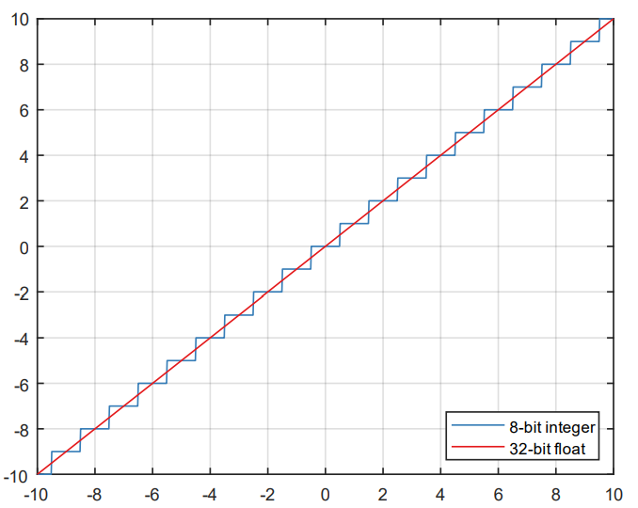
FIGURE 15. Effect of quantizing 32-bit floats to 8-bit integers

Methodology
This thesis was conducted in collaboration with Visy Oy to explore potential edge deployment solutions for their existing deep learning-based systems. The primary objective was to evaluate various deep learning models on three distinct hardware architectures. A model-hardware combination was considered suitable for real-time object detection if it met the following criteria:
- Achieved a minimum of 5 FPS.
- Ensured consistent latency.
- Maintained a modest yet reliable accuracy.
These benchmarks guided the methodology in identifying and implementing a quantized model optimized for edge devices, ensuring real-time performance without compromising critical metrics such as inference speed and detection accuracy. This section details the methodology adopted for achieving real-time inference speeds of a CNN-based object detection model on tiny edge devices. The methodology is structured into the following steps:

Hardware Selection and Comparison
To achieve real-time object detection on edge devices, three different hardware setups were selected based on their pricing, availability, and expected performance as determined by their specifications. The chosen devices represent leading vendors in edge computing technology: NVIDIA, Intel, and Google. The selected hardware configurations were:
- NVIDIA Jetson Nano
- Raspberry Pi 4 B paired with Intel Neural Compute Stick 2 (NCS 2)
- Axis Q1615-LE Mk III network camera equipped with Google Coral EdgeTPU
Table 1: Key Specifications of the Selected Hardware
Device | DL Accelerator | CPU | Memory | Computing Speed | SDK | Additional Features
NVIDIA Jetson Nano | NVIDIA 128-core Maxwell GPU | ARM A57, QuadCore @ 1.43 GHz | 4 GB (shared) | 472 GFLOPS | TensorRT | Strong video processing capabilities, programmable
Raspberry Pi 4 B + Intel NCS 2 | Intel Movidius Myriad VPU | ARM A72, QuadCore @ 1.5 GHz | 500 MB (NCS 2) | 4000 GFLOPS | OpenVINO | Flexible, works on any host PC
Axis Q1615-LE Mk III | Google Coral EdgeTPU | ARTPEC-7 | 8 MB SRAM | 4000 GFLOPS | TensorFlow Lite | Compact design with DL acceleration through Axis SDK

Detailed Analysis of Each Device

NVIDIA Jetson Nano
  - Advantages:
    - The 128-core Maxwell GPU provides robust deep learning acceleration, particularly for tasks involving image processing and computer vision.
    - Strong video decoding and encoding capabilities make it well-suited for real-time video-based object detection.
    - The TensorRT SDK optimizes model performance, enabling high inference speeds.
  - Limitations:
    - The 4 GB memory is shared between the CPU and GPU, potentially leading to resource contention, especially when processing large models or datasets.
    - Slightly older CPU architecture (ARM A57) compared to Raspberry Pi.

Raspberry Pi 4 B + Intel NCS 2
  - Advantages:
    - The ARM A72 Quad-Core CPU is a slight upgrade over the Jetson Nano's CPU, offering improved general-purpose computing performance.
    - The Intel Movidius Myriad VPU on the NCS 2 is a dedicated deep learning accelerator, leaving the Raspberry Pi's CPU memory untouched for other tasks.
    - Supports OpenVINO SDK, which provides optimized model inference pipelines for Intel's hardware.
    - Modular setup: The NCS 2 can be plugged into any compatible host device, offering flexibility.
  - Limitations:
    - The VPU memory is limited to 500 MB, which could be a bottleneck for larger models.
    - The GPU on the Raspberry Pi (Broadcom BCM2711) is significantly weaker than the Jetson Nano's Maxwell GPU, reducing its suitability for GPU-based tasks.

Axis Q1615-LE Mk III with Google Coral EdgeTPU
  - Advantages:
    - The Google Coral EdgeTPU is specifically designed for TensorFlow Lite models, offering exceptional inference speeds with optimized lightweight architectures.
    - Compact and self-contained: The processing units are built directly into the network camera, simplifying deployment.
    - The ARTPEC-7 SoC combines efficient processing and network handling capabilities for standalone operation.
  - Limitations:
    - The 8 MB SRAM on the EdgeTPU restricts the size of models that can be run directly on the device. For larger models, parameter data must be fetched from external memory, introducing latency.
    - High cost: The Axis Q1615-LE Mk III is significantly more expensive than the other two devices. This must be weighed against its simplicity and integration benefits.

Price-Performance Considerations
The Axis Q1615-LE Mk III offers unparalleled ease of deployment since it integrates all processing and networking components within a single device. However, its high cost may not be justifiable for budget-conscious applications. In contrast, the Jetson Nano and Raspberry Pi 4 B with NCS 2 are more affordable but require additional hardware, such as external cameras, for full deployment. This increases the complexity of setup and integration.

Memory Management Differences
- The Jetson Nano shares its 4 GB memory across the CPU and GPU, potentially leading to resource constraints during heavy computational loads.
- The Raspberry Pi with NCS 2 has separate memory pools for the CPU and VPU, allowing more efficient memory usage for parallel tasks.
- The EdgeTPU on the Axis camera is optimized for small TensorFlow Lite models. While this allows for compact and fast processing, larger models may suffer from increased latency due to reliance on external memory.

SDK and Development Environment
- Jetson Nano: Supports TensorRT, a powerful SDK for optimizing and deploying deep learning models on NVIDIA hardware.
- Raspberry Pi with NCS 2: Leverages OpenVINO, Intel's toolkit for deep learning inference, providing flexibility and performance optimization for a wide range of Intel hardware.
- Axis Q1615-LE Mk III: Utilizes TensorFlow Lite with additional support from Axis' ACAP SDK, tailored for seamless deployment on the EdgeTPU.

Model Conversion
Due to each device being run on different accelerators and utilizing different SDKs, separate conversion processes had to be employed. The process typically consists of converting the trained model to some open-source intermediate representation.

TensorRT
The TensorRT conversion process plays a crucial role in optimizing trained neural networks for deployment on NVIDIA hardware. It ensures that deep learning models achieve maximum inference speed, reduced memory consumption, and efficient execution, which are critical for real-time performance on edge devices. The workflow begins with a trained neural network, typically developed using popular frameworks like TensorFlow or PyTorch. However, since these models are often not hardware-optimized for edge devices, they need to undergo a conversion process to produce an optimized inference engine.
The first step in this process involves converting the trained model into an intermediate representation (IR). This is typically done using ONNX (Open Neural Network Exchange), which is an open-source standard for representing machine learning models. ONNX allows models to be portable across different platforms and frameworks, serving as a bridge for TensorRT to optimize models efficiently. By utilizing ONNX, developers can ensure that models trained in frameworks like TensorFlow or PyTorch can be seamlessly integrated into the TensorRT pipeline.
Once the model is in the ONNX format, TensorRT applies a series of optimization techniques to enhance its performance. These include layer and tensor fusion, which combine multiple operations or layers into a single computational kernel. This reduces execution overhead by minimizing redundant operations. Another key optimization is precision calibration, where the model's precision is converted from FP32 (32-bit floating-point) to FP16 (16-bit floating-point) or INT8 (8-bit integer). This quantization significantly reduces the model's size and speeds up inference while maintaining acceptable accuracy. Additionally, kernel auto-tuning is performed to automatically select the most efficient kernels for the target hardware, ensuring the best execution speed for specific operations.
TensorRT also incorporates dynamic tensor memory optimization, which reduces memory usage by dynamically allocating and managing tensor resources during runtime. For further efficiency, multi-stream execution is enabled, allowing the model to process multiple inference requests in parallel. This maximizes hardware utilization and boosts overall throughput, which is especially useful for real-time applications requiring high frame rates. TensorRT conversion workflow can be seen in Figure 16.
FIGURE 16. TensorRT conversion workflow
At the end of this process, TensorRT generates an optimized inference engine. This engine is a serialized representation of the model, specifically tailored for NVIDIA hardware like the Jetson Nano. The optimized engine ensures that all layers and computations are highly efficient and hardware-accelerated, enabling real-time inference even on resource-constrained edge devices. The figure illustrates the TensorRT conversion workflow. On the left side, the process starts with the trained neural network. The middle section highlights the key optimization steps, including layer and tensor fusion, precision calibration, kernel auto-tuning, and multi-stream execution. These optimizations work together to improve inference speed and reduce memory consumption. On the right side, the final output is an optimized inference engine ready for deployment.

TensorFlow Lite
TensorFlow Lite, an open-source machine learning toolkit developed by Google. This toolkit is specifically designed for mobile and IoT devices, where computing power and memory resources are limited.
- On-device machine learning and inference optimization: TensorFlow Lite supports running machine learning models directly on devices, which reduces latency and improves efficiency compared to cloud-based inference.
- Optimization technologies: TensorFlow Lite provides several techniques to optimize models, including:
  - Post-training quantization: This technique reduces the model's size and speeds up inference by approximating model weights to lower precision.
  - Quantization-aware training: This method incorporates quantization into the training process to minimize the accuracy loss when converting a model to lower precision.
  - Pruning: This reduces the number of parameters in a model by eliminating weights that have minimal impact, resulting in a smaller and faster model.
- Further optimization for EdgeTPU: TensorFlow Lite models can be further optimized for specialized hardware accelerators like Google's EdgeTPU, which is designed to run machine learning models more efficiently on edge devices. Tools like Google Coral help with this optimization process.
FIGURE 17. EdgeTPU optimization workflow. Copied from [44]

OpenVINO
OpenVINO is an open-source toolkit developed by Intel for optimizing machine learning models to run efficiently on Intel hardware platforms, such as Intel CPUs, Intel GPUs, and the Myriad VPU (Vision Processing Unit). Here are the key aspects of OpenVINO:
- Optimization for Intel platforms: OpenVINO helps convert and optimize machine learning models so they can run efficiently on Intel hardware. It automatically transforms and optimizes layers from different machine learning frameworks (such as TensorFlow, PyTorch, and others) into formats compatible with Intel platforms.
- No training support: OpenVINO does not support the training of machine learning models. It is focused on optimizing models that have already been trained using other frameworks.
- Post-training optimization tools: OpenVINO includes several optimization techniques to enhance model performance, such as:
  - Quantization: Reduces the precision of model weights to lower bit-widths, decreasing memory usage and increasing inference speed.
  - Pruning: Removes unnecessary model parameters to make the model smaller and more efficient without significantly affecting accuracy.
OpenVINO is widely used for deploying machine learning models on Intel hardware, making it suitable for edge and embedded systems, as well as for optimizing performance in various AI-driven applications.
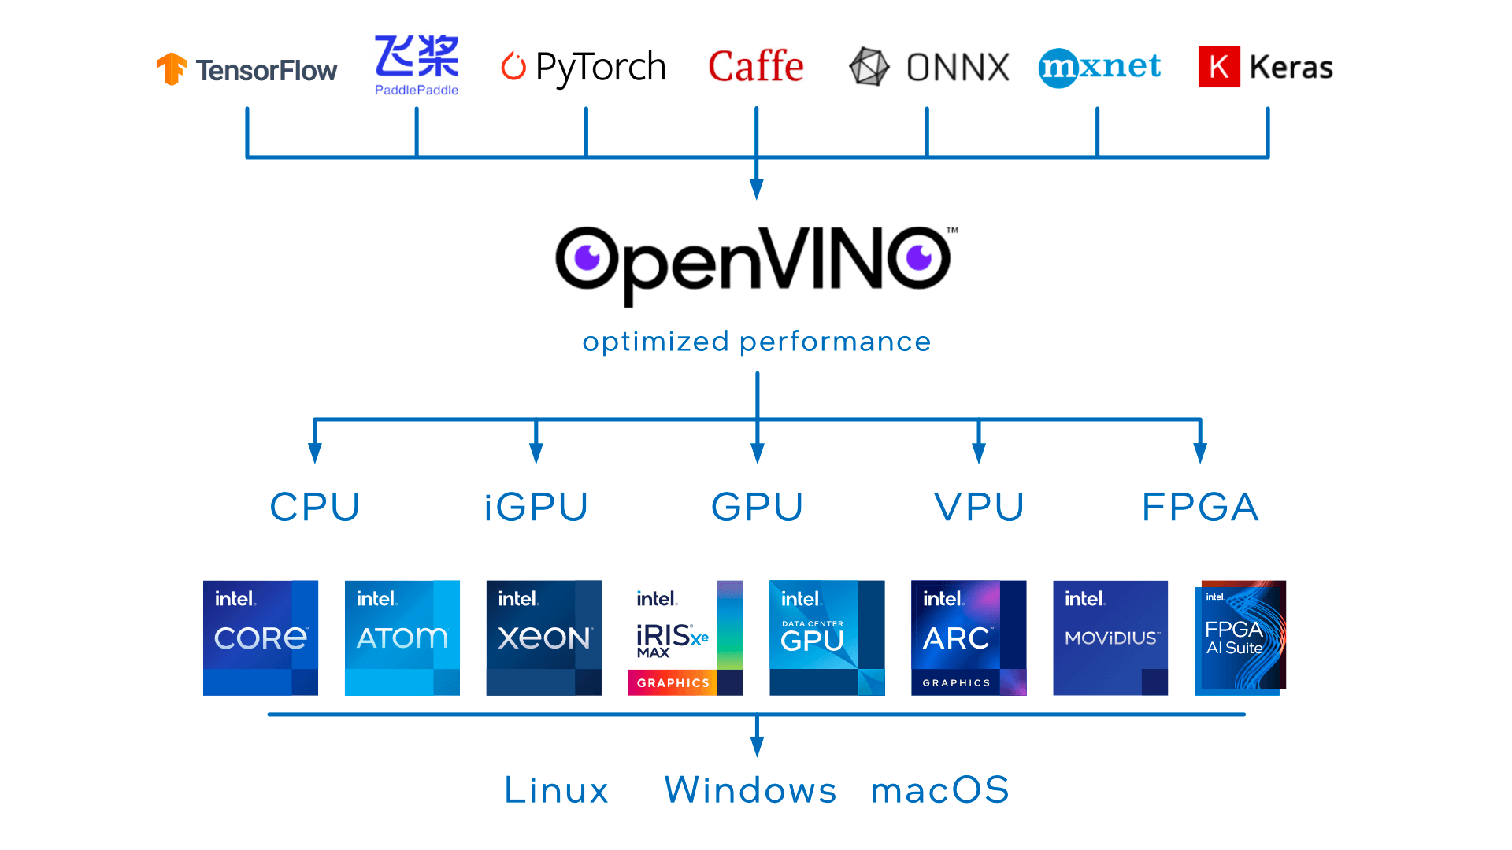
FIGURE 18. OpenVINO workflow. Copied from [45]

Measurement setup
Two different measurements were conducted, one for accuracy, and one for system stress levels and latency. The accuracy and latency test were performed for all devices, but the system stress levels were not measured from the Axis camera, due to it being a system with less control over as a programmer.

Accuracy evaluation
The accuracy of the models was evaluated using the mAP-metric, which can be calculated as the area under the precision-recall curve. In object detection, a prediction is measured as correct or true positive, if its IoU is over a predetermined threshold with the ground-truth box. If the IoU is less than the threshold, the bounding box is determined as incorrect and a false positive. Otherwise, if there was no object detected or the class was wrong, when there was a ground-truth box, the prediction is labeled as a false negative. Precision measures, what portion of the predictions labeled as positive were actually correct, while recall measures how well we found all the positive samples in the dataset. [12, pp. 92- 98] The precision and recall values can then be taken at multiple IoU thresholds and plotted as is seen in Figure 19.
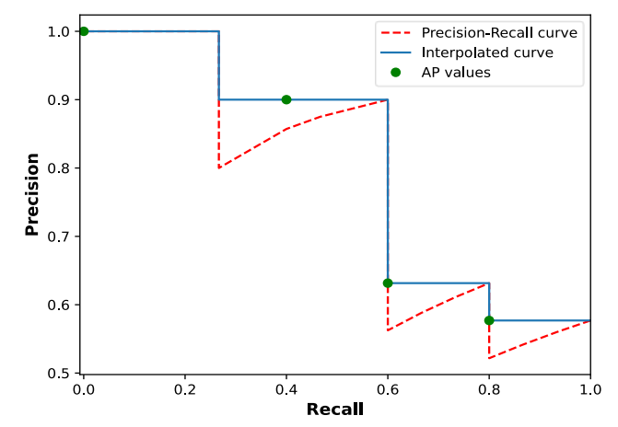
FIGURE 19. 4-point interpolated Precision-Recall curve
Finally, the mean average precision (mAP) can be computed. To ease the computing, the area under the curve is often calculated by taking evenly spaced recall values and interpolating the precision value at each of the taken values into the highest value to the right, as is seen in Figure 19. The equation is given as follows
$mAP = 1 n ∑Pinterp(r)$ 𝑛 𝑟=0 , (12)
where n = number of samples to interpolate and Pinterp is a function giving the interpolated value at r [46, p. 313].
The accuracy in the measurements was computed on a dataset of 997 license plate images, using pycocotools Python API from the authors of the COCO dataset [47]. The program uses 101-point interpolation to compute two mAP metrics. The first one calculates the mAP score at an IoU threshold of 0.5 and is often denoted mAP@0.5. The second one is calculated as an average of mAP scores at IoU thresholds from 0.5 to 0.95, with a spacing of 0.05, and is denoted mAP@0.5:0.95.

Stress test
A stress test was performed on devices to see, how consistent the systems were at performing inference and image processing over 10 minutes with a batch size of one. On the Axis camera, only the latency was monitored. On other devices, the monitored statistics were the latency, CPU/GPU/VPU temperature, CPU/GPU clock frequency and utilization, and power consumption. On Jetson Nano and Raspberry Pi, the connected peripherals were a monitor, keyboard, mouse, and an ethernet cable, but no other software was running. On Jetson Nano, the Python package jetson-stats [48] was used to monitor all the statistics, which provided an easy-to- se A I or NVIDIA’s tegrastats [49]. The measurements were performed by inputting images with a batch size of one to the model and latency was measured from the inference engine call to the end of post-processing, such as non-max suppression, if necessary.
In these experiments, OpenCV was used to read images from the disk and process them into appropriate sizes for the neural networks before each inference, but the time spent pre-processing was not taken into consideration in inference speed. This, however, meant that roughly 30 milliseconds of potential inference time were used for processing on the CPU between each inference on the Jetson Nano and Raspberry Pi. On Jetson Nano, The CPU and GPU utilization were measured as average usage over the polling period (500 ms), while others were instantaneous values also taken every 500 ms. The other statistics, such as power consumption, were queried more as an indicative value rather than the absolute truth, as there was no certainty the peak values would be found without hindering the system with too high polling rates. In theory, though, power consumption of at least 10 W should be expected on the Jetson Nano, as such power supply is required by the manufacturer to run the board at maximum speed. The same measurement method was utilized on the Raspberry Pi and NCS2, however, the statistics were queried through Raspberr ’s b lt-in vcgencmd, psutil [50], and Intel’s Inference Engine API [51]. These provided the CPU utilization, clock frequencies, and CPU and VPU temperatures, but information such as VPU utilization and system power consumption were missing. The power consumption was measured by powering the Raspberry Pi through the GPIO pins during inference, giving a good indicator of how much power the system consumes in total.

